No | Item | Image
1 | Hair Straightener | 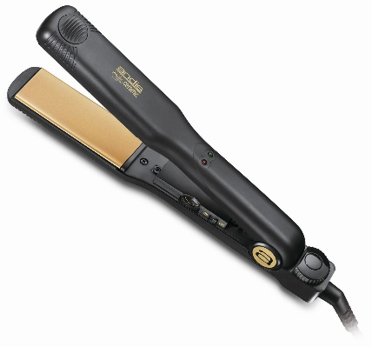  Andis Hair Straightener
2 | Makeup Bag | 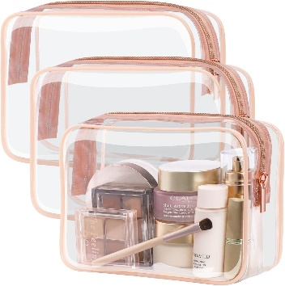

Component of the makeup collection kit

No | Item | Image | Specification
 | Concealer | 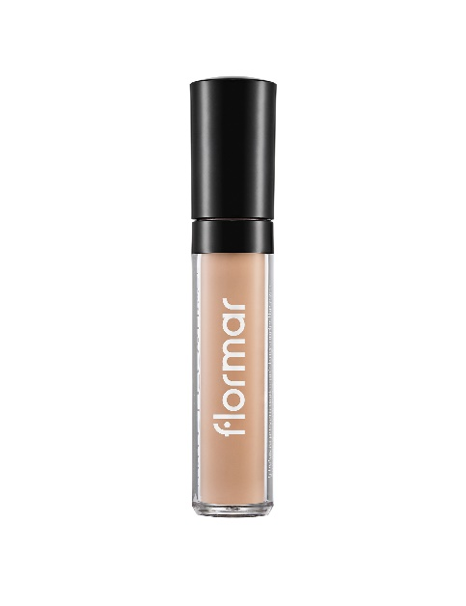 |  |  |  |  |  |  | Perfect Coverage Liquid Concealer
 | Blush | 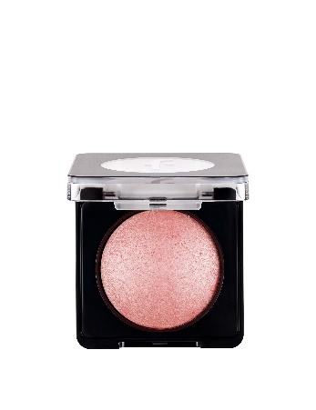 |  | 041 Romantic Salmon
 | Highlighter | 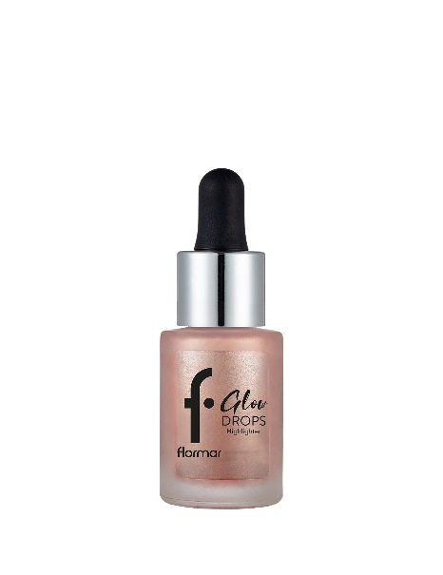 |  | 002 sunglow
 | Mascara | 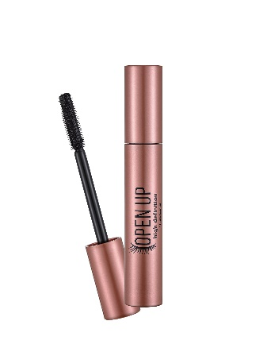 |  | Open up Hd mascara
 | Lipsticks | 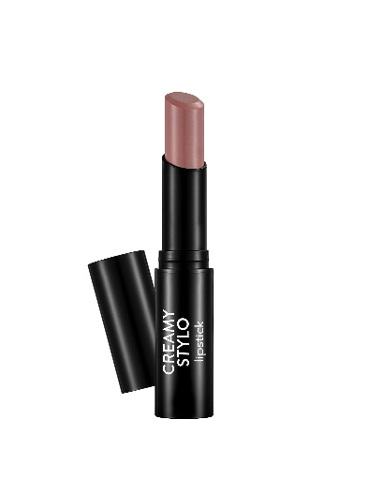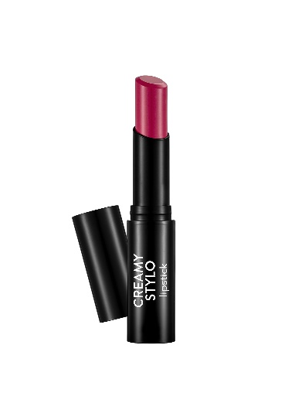 |  |  |  |  |  |  |  | 010 Nude  004 Raspberry
 | Lip gloss | 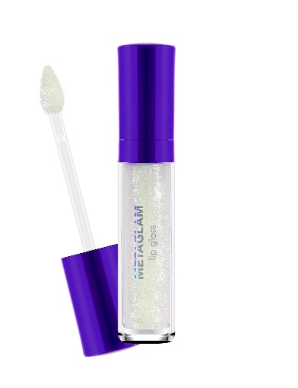 |  |  |  |  |  |  |  | 001 Digital Horizon
 | Eyeliner | 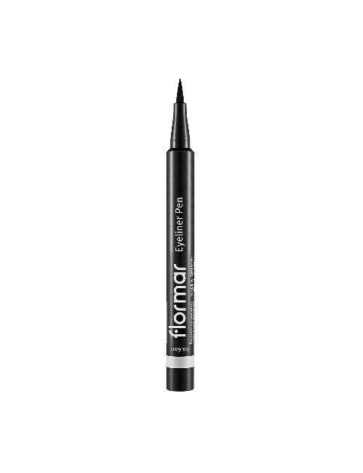 |  |  |  |  |  |  |  | Eyeliner pen black flormar
 | Lip linear | 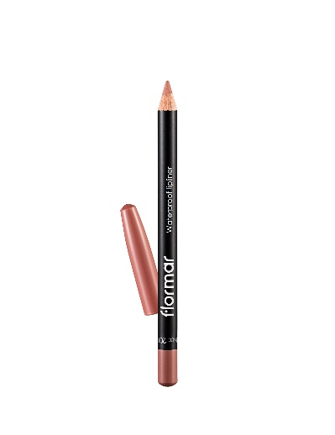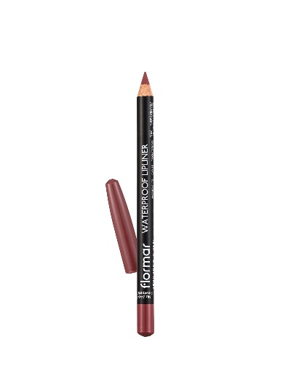 |  |  |  |  |  | 201 Naturally Nude  202 soft pink brown
 | Beauty blender | 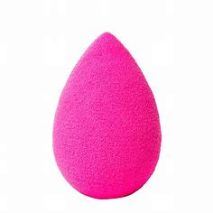
 | Makeup brushes | 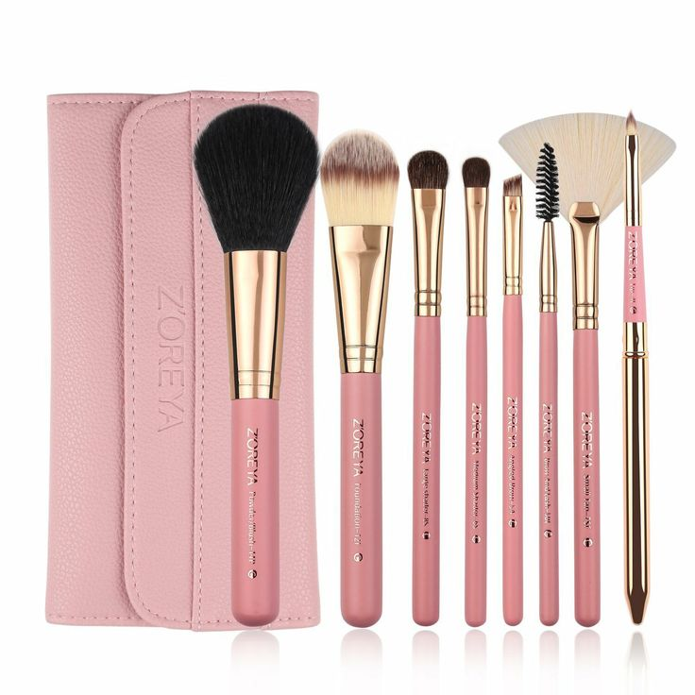 |  |  | Makeup brushes set
 | Eye shadow | 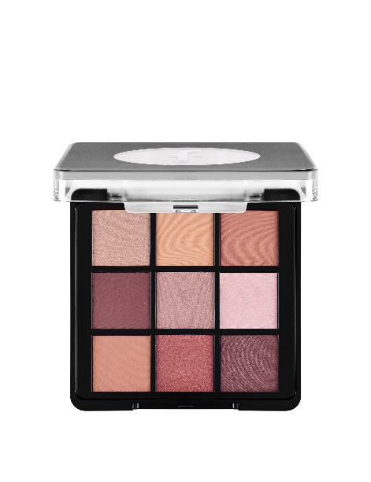 |  |  | 006 Felt Cute
 | Contour | 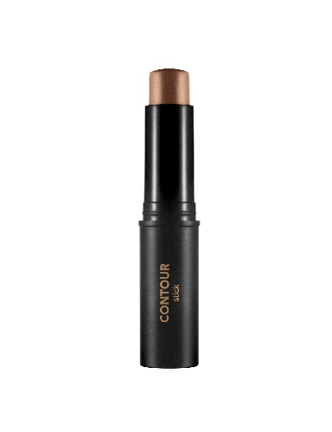 |  |  | 003 Medium Deep
 | Primer | 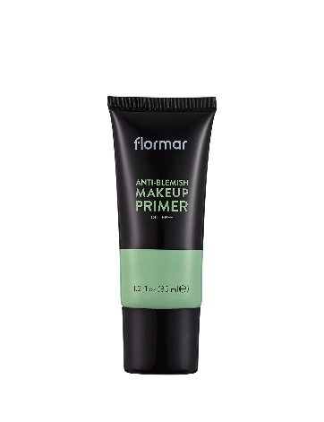 |  |  |  | Anti-blemish makeup primer
 | Setting Spray | 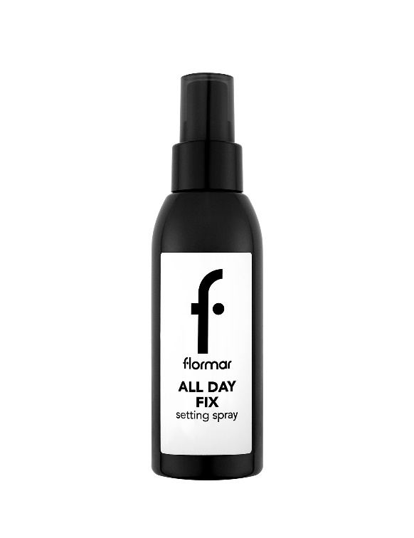 |  |  |  | All day fix setting spray
 | Foundation | 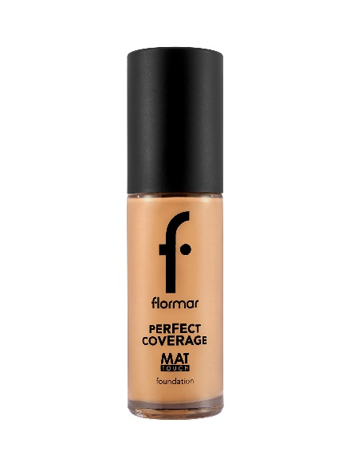 |  |  |  |  | 134 Golden Honey Foundation

